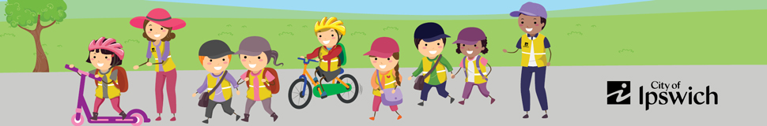
Active School Travel Plan
School profile
School name
Office phone number
Number of Students (total)
Number of Families
Number of classes (Prep to Y6)
School Bell Times | Please complete
Best way to communicate with families | Please complete

Traffic Issues at the School
- School drop off -
- School pick up -
- Local streets -

Active Travel Objectives
(Choose from the following, or add in additional)
Objectives | Strategies
Decrease school traffic congestion | Implement a ‘walking school bus’
Improve school crossing safety | Implement a ‘cycling school bus’
Foster the school community and promote social connections | Road safety education
Promote active travel benefits | Bike skills workshops / education
Promote local infrastructure for riding and walking

Improving student bike riding skills and confidence

Active Travel Working Group
Name | Role | Email
 | School Principal
 | Deputy Principal
 | School AST Champion
 | P&C member
 | Walking/ cycling school bus leaders

Site map
(Map of school highlighting potential walking routes).

Distribution of staff/students/community (Dept. of Education can supply this through the Queensland Government Statistician’s Office)

Term 4
Strategy | Activity | Resources | Timeframe
Meet with Council and create an Active School Travel Action Plan.
Conduct a baseline Parent Survey.
Conduct a baseline Kids Survey.
Conduct a baseline ‘Hands Up’ Survey.
Sign MOU with Council.

Term 1
Strategy | Activity | Resources | Timeframe
Launch active travel.
Hold active travel days.
Record participation of active travel activities.
Conduct ‘Hands Up’ Survey.

Term 2
Strategy | Activity | Resources | Timeframe
Optional: Hold active travel launch day.
Hold active travel days.
Record participation of active travel activities.
Conduct ‘Hands Up’ Survey.

Term 3
Strategy | Activity | Resources | Timeframe
Optional: Hold active travel launch day
Hold active travel days.
Record participation of active travel activities.
Conduct ‘Hands Up’ Survey.

Term 4
Strategy | Activity | Resources | Timeframe
Optional: Hold active travel launch day
Hold active travel days.
Record participation of active travel activities.
Conduct ‘Hands Up’ Survey.

School Data Collection
(Record your participation data here for active travel initiatives/ events/ activities).

Parent Surveys
Date Distributed | No. of Survey Responses

Classroom ‘Hands Up Surveys’
Number of classes:
Date | No. of Classes Responded

Activities
Activity | Date | No. of participants | Comments

